UNIVERSITY OF GHANA
DEPARTMENT OF STATISTICS AND ACTUARIAL SCIENCE
ASTA 607: COMPUTATIONAL STATISTICS

MICHAEL OFOSU – 22424585

- a. Dataset{crabs}
?crabs
The crabs data frame has 200 rows and 8 columns, describing 5 morphological measurements on 50 crabs each of two colour forms and both sexes, of the species Leptograpsus variegatus collected at Fremantle, W. Australia.

b. Load dataset and display its structure
str(crabs)
'data.frame': 200 obs. of 8 variables:
$ sp : Factor w/ 2 levels "B","O": 1 1 1 1 1 1 1 1 1 1 ...
$ sex : Factor w/ 2 levels "F","M": 2 2 2 2 2 2 2 2 2 2 ...
$ index: int 1 2 3 4 5 6 7 8 9 10 ...
$ FL : num 8.1 8.8 9.2 9.6 9.8 10.8 11.1 11.6 11.8 11.8 ...
$ RW : num 6.7 7.7 7.8 7.9 8 9 9.9 9.1 9.6 10.5 ...
$ CL : num 16.1 18.1 19 20.1 20.3 23 23.8 24.5 24.2 25.2 ...
$ CW : num 19 20.8 22.4 23.1 23 26.5 27.1 28.4 27.8 29.3 ...
$ BD : num 7 7.4 7.7 8.2 8.2 9.8 9.8 10.4 9.7 10.3 ...

c. Frequency table for species and sex
freq_table <- table(crabs$sp, crabs$sex)
print(freq_table)

F M
B 50 50
O 50 50

d. Barplot for group composition

freq_table <- table(crabs$sp, crabs$sex)
row.names(freq_table) <- c("Blue", "Orange")
colnames(freq_table) <- c("Male","female")
print(freq_table)
par(mar = c(4,4,2,2))
barplot(freq_table, beside = T, legend = TRUE,col = 4:5,xlab = "Sex",
ylab = "Frequency",main = "Group Compositions")

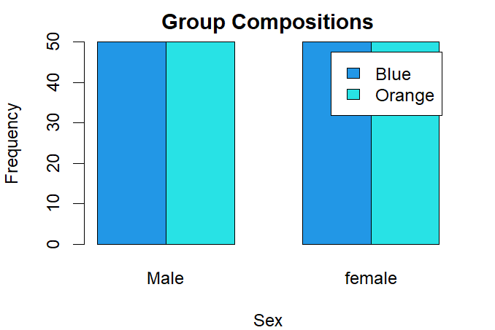

e. The dataset is balanced across all the four groups

- Boxplots
par(mfrow = c(1,2), mar = c(4, 4, 2, 1))
boxplot(crabs$BD ~ crabs$sp, col = 4:5, xlab = "Species",
ylab = "Body Depth (BD)", main = "Boxplot BD by Sp")
boxplot(crabs$BD ~ crabs$sex, col = 4:5, xlab = "Sex",
ylab = "Body Depth (BD)", main = "Boxplot BD by Sex")
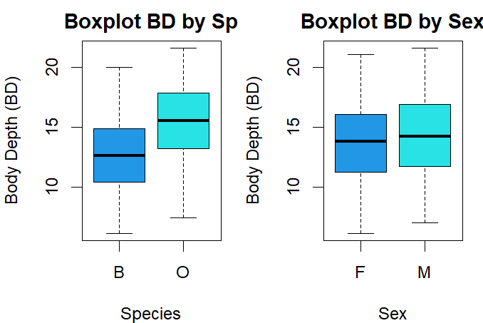

b. central tendency and variability

mean_bd <- tapply(crabs$BD, list(crabs$sp, crabs$sex), mean)
print(round(mean_bd, 2))
median_bd <- tapply(crabs$BD, list(crabs$sp, crabs$sex), median)
print(round(median_bd, 2))
var_bd <- tapply(crabs$BD, list(crabs$sp, crabs$sex), var)
print(round(var_bd, 2))

 | Mean |  | Median |  | Variance
 | Male | Female | Male | Female | Male | Female
Blue | 11.82 | 13.35 | 11.6 | 13.6 | 7.58 | 10.24
Orange | 15.63 | 15.32 | 15.65 | 15.0 | 7.58 | 12.44

No outliers with very marginal variability between the groups

- Histogram of CL by species
hist(crabs$CL[crabs$sp == "B"],main = "Histogram of CL(B)",
xlab = "Species Blue",col = 4)
hist(crabs$CL[crabs$sp == "O"],main = "Histogram of CL(O)",
xlab = "Species Orange", col = "orange")
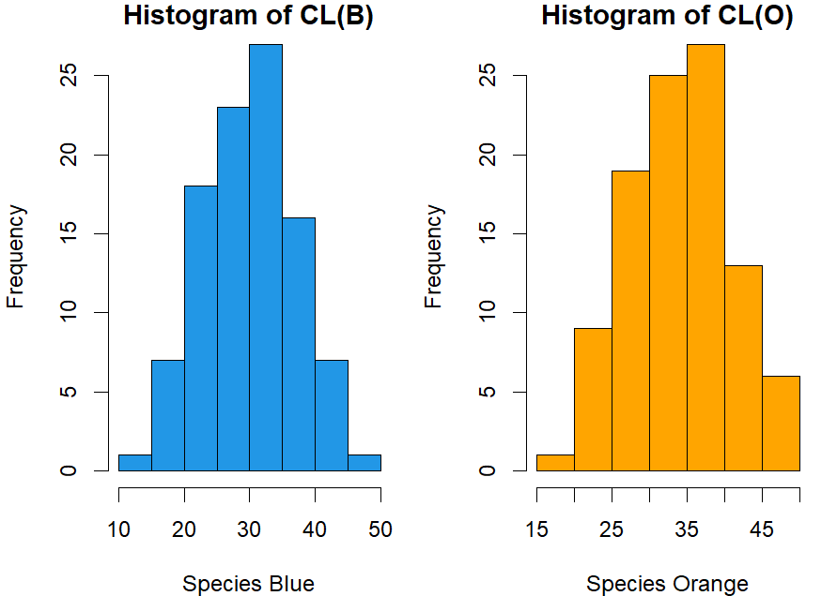

The shapes of the both distributions look normally distributed but they are all a little skewed to the left.
The modality of species blue is more between 33 and 35, with the modality of specie orange is between 38 to 40.

- Comparison mean
comp_mean <-aggregate(cbind(FL, RW, CL, CW, BD) ~ sp + sex,
data = crabs,mean)
print(comp_mean)

print(comp_mean)
sp sex FL RW CL CW BD
1 B F 13.270 12.138 28.102 32.624 11.816
2 O F 17.594 14.836 34.618 39.036 15.632
3 B M 14.842 11.718 32.014 36.810 13.350
4 O M 16.626 12.262 33.688 37.188 15.324

- Scatter plot
scatterplot <- pairs(crabs[, 4:8],
col = 4:8, main = "Scatterplot Matrix")

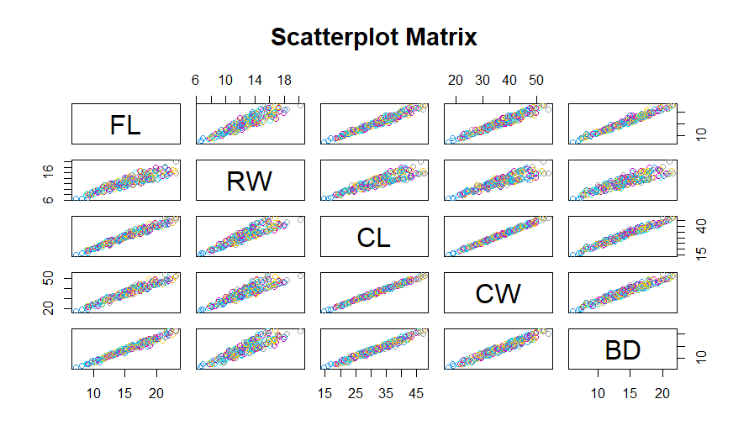

Every pair of variables(FL, RE, CL CW and BD) exhibits a strong positive linear relationship between each other as seen in the plot. The nature of their relationships show little scatter around the plots

- Statistical report
The data set(Crabs ) has a total of 200 observations, Balanced between species and sex. It was observed that the Males have larger mean measurements than females across all five variables, though the difference looks smaller.

